**Contents**

**Four-step dimensional design process** 2

**Star Schema** 3

**Snowflake Schema** 4

**Business Description** 6

# **Four-step dimensional design process**

Step1: Selecting the Business Process

Sales accounting:

* It is a low-level activity performed by an organization
* It can be supported by an operational system
* It generates key performance metrics

Step2: Declare the Grain

One row per sale of individual product to a customer by specific employee in the store for a concrete date.

Step3: Identify the Dimensions

Dimension date: contains all dates for a determined period with columns like year, quarter, month and day.

Dimension products: contains information about products and their categories.

Dimension customers: contains information about customers and their geo data.

Dimension employees: contains information about employees and their geo data.

Dimension stores: contains information about stores, their managers and geo data.

Step4: Identify the Facts

Fact sales: contains information about sales.

Measures: amount, fact table record count.

# **Star Schema**

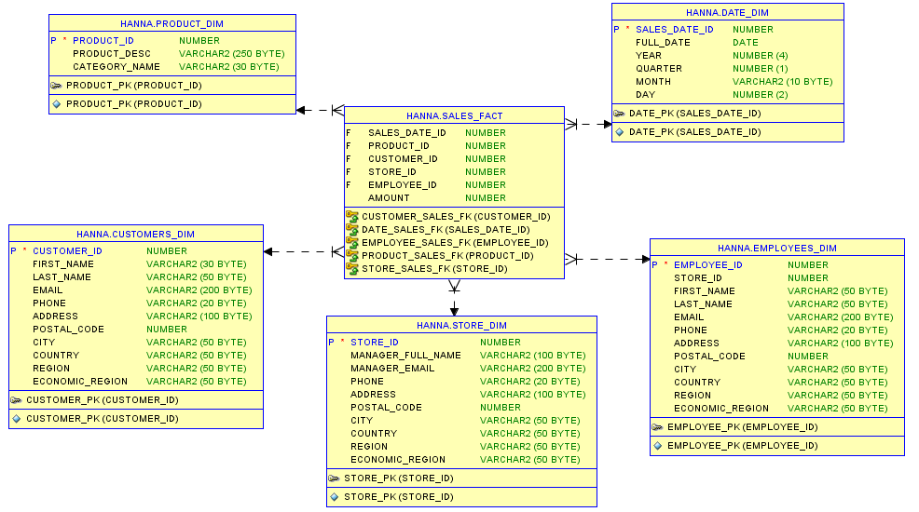

# **Snowflake Schema**

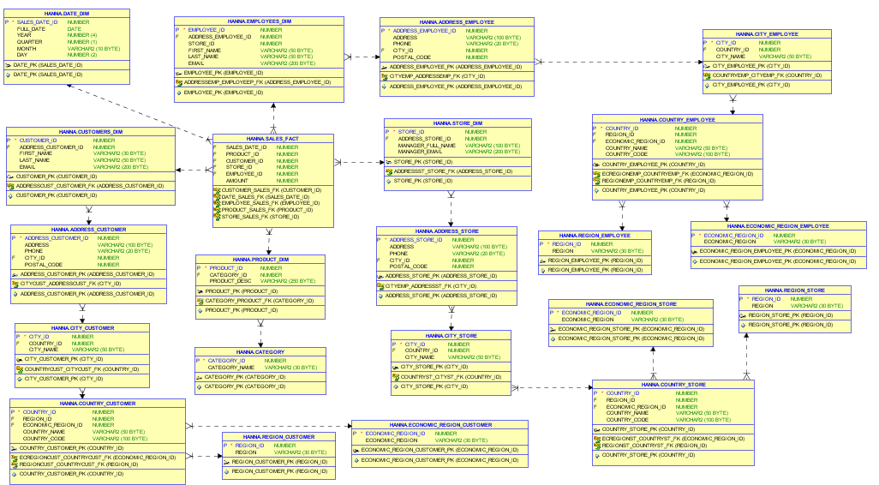

# **Business Description**

1. **Business background**

My chosen business is airline ticket sales service. The main goal of this business is selling of tickets and receiving the profit.

Key business processes are looking for a suitable ticket for client, making reservation of seats in the airplane and getting payment.

1. **Problems because of poor data management**

The problems of poor data management causes the impossibility of an in-depth analysis of the demand for air tickets, profit analysis, having full data about clients and their orders.

1. **Benefits from implementing a Data Warehouse**

Data Warehouse will let business to store all data about ticket sales, aggregate it, do visualization, analyze data and make predictions for the future.